**UBER DATA ANALYSIS REPORT**



**Plotting the trips by hours in a day**

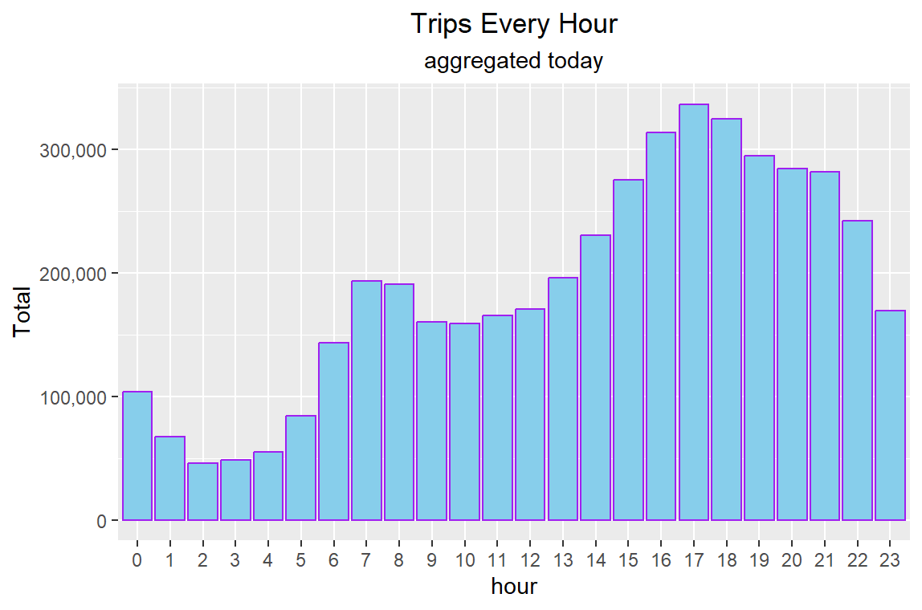

This plot shows the number of Uber trips taken during each hour of the day, aggregated over the entire dataset. Here are some key insights:

1. Peak Hours: The busiest hours for Uber trips are in the evening, with the highest peak occurring around 6-7 PM (18:00-19:00). This likely corresponds to people leaving work and heading out for evening activities.
2. Evening Trend: There's a sustained high level of trips from about 5 PM to 11 PM (17:00-23:00), indicating busy evening hours for Uber.
3. Morning Rush: There's a smaller but noticeable peak in the morning hours, particularly around 8-9 AM, likely corresponding to the morning commute.
4. Lowest Activity: The fewest trips occur in the early morning hours, particularly between 3-5 AM, when most people are asleep.
5. Gradual Increase: Trip numbers start to increase steadily from about 6 AM onwards, coinciding with the start of the typical workday.
6. Late Night Activity: There's still significant activity late at night, with a gradual decrease from the evening peak until about 2-3 AM, possibly reflecting people returning from nighttime activities.
7. Midday Plateau: There's a relatively stable number of trips during midday hours (10 AM to 4 PM), lower than the peak hours but still substantial.
8. Scale: The busiest hour sees over 350,000 trips, while the quietest hour still has over 50,000 trips, indicating consistent demand even during off-peak times.

This data could be valuable for Uber to optimize driver availability, predict demand, and potentially implement surge pricing during peak hours. It also provides insights into the daily rhythms of the city and its inhabitants' transportation needs.

**Plotting trips by hour and month**

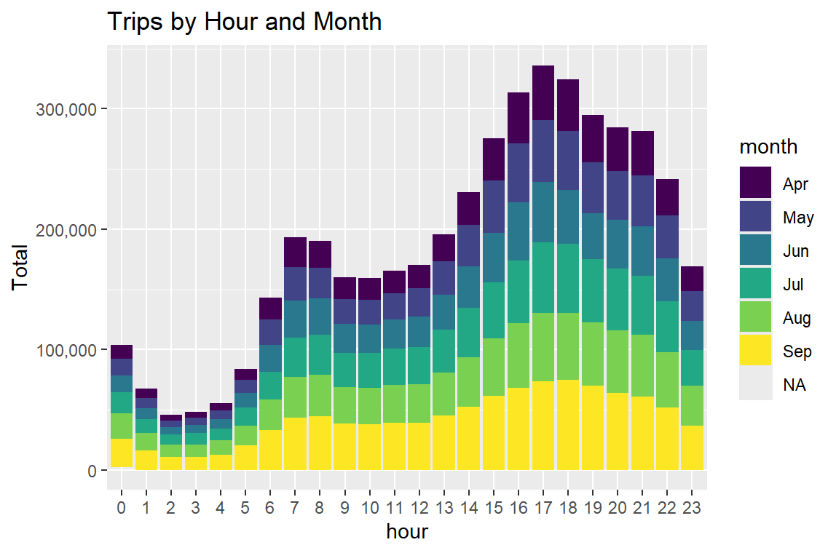

This stacked bar chart provides a detailed view of Uber trips by hour and month. Here are some key insights:

1. Overall Pattern: The general pattern of trips throughout the day is consistent across months, with peaks during evening hours and troughs in early morning hours.

2. Growth Over Time: There's a clear increase in trip volume from April to September. September (yellow) has the largest share of trips for most hours, indicating growth in Uber usage over these months.

3. Evening Peak: The busiest time for Uber trips is consistently between 5 PM and 8 PM (17:00-20:00) across all months, likely corresponding to post-work commutes and evening activities.

4. Morning Rush: There's a smaller but noticeable peak around 8-9 AM, representing morning commutes. This peak seems relatively consistent across months.

5. Seasonal Variations:

* Summer months (June, July, August) show higher trip volumes, especially in evening hours.
* September has the highest overall trip volume, possibly due to return from summer holidays and resumption of regular work/school schedules.

6. Late Night Activity: There's significant late-night activity (11 PM - 2 AM) that increases in the summer months, possibly due to more nightlife during warmer weather.

7. Midday Consistency: The midday hours (10 AM - 4 PM) show relatively stable demand across all months, but with gradual growth from April to September.

8. Early Morning Lull: The hours between 3 AM and 5 AM consistently show the lowest activity across all months.

9. Weekend Effect: While not explicitly shown, the higher volumes in evening and late-night hours, especially in summer months, might indicate increased weekend activity.

10. Business Growth: The overall increase in trip volume from April to September could indicate Uber's growing market presence or general increase in demand for ride-sharing services.

These insights could be valuable for Uber to:

* Adjust driver incentives based on monthly and hourly demand patterns
* Plan marketing campaigns targeting specific times of day or seasons
* Optimize surge pricing strategies
* Understand and prepare for seasonal variations in demand

**Plotting data by trips during every day of the month**

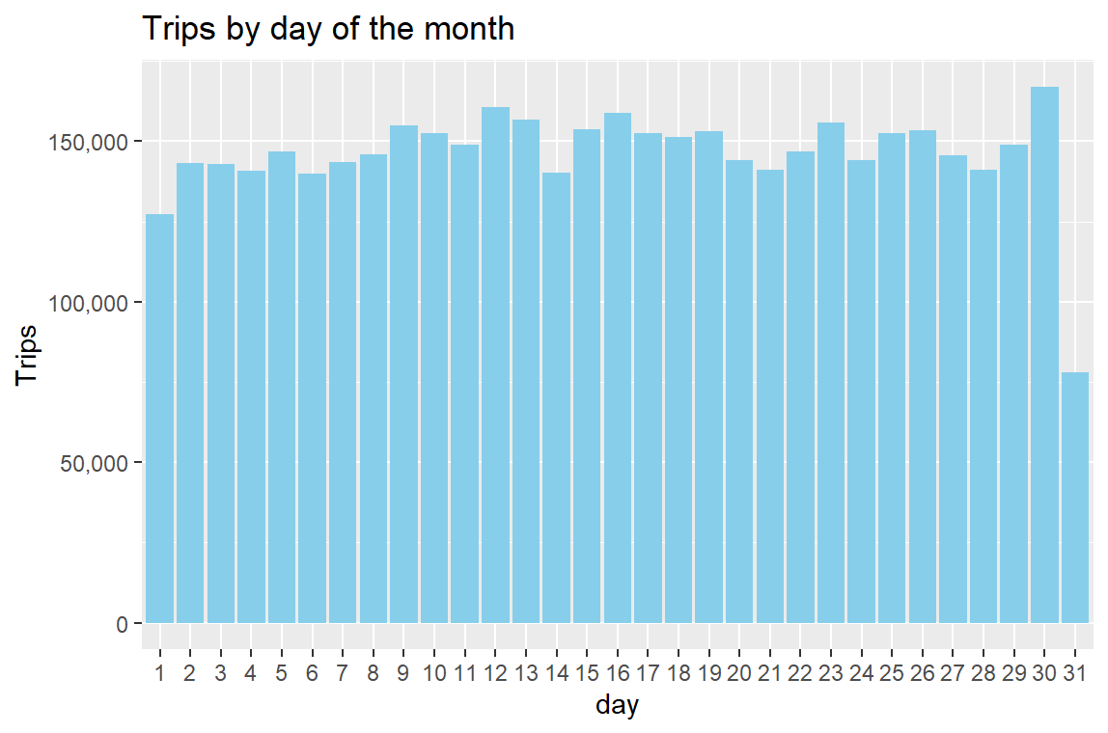

This bar chart shows the number of Uber trips taken on each day of the month, aggregated across all months in the dataset. Here are some key insights:

1. Overall Pattern: There's a relatively consistent level of trips across most days of the month, with some notable exceptions.

2. End-of-Month Peak: The 30th and 31st of the month show significantly higher trip numbers. This could be due to various factors such as:

* End-of-month paydays leading to increased social activities
* Month-end business activities
* Possible data aggregation from months with fewer days

3. Start-of-Month Dip: There's a noticeable dip in trips on the 1st of the month. This could be due to:

* Reduced activity following end-of-month celebrations
* Possible data recording issues at month transitions

4. Mid-Month Fluctuations: There are some fluctuations mid-month, with slight peaks around the 12th-13th and 16th-17th. These could represent bi-weekly pay periods influencing trip patterns.

5. Weekend Effect: While not explicitly shown, some of the fluctuations could be due to weekends falling on different days each month, which might average out over the dataset.

6. Consistency: Apart from the start and end of the month, most days show between 140,000 to 160,000 trips, indicating a fairly stable daily demand for Uber services.

7. Lowest Day: The 1st of the month has the lowest number of trips, which is significantly lower than other days.

8. Highest Days: The 30th and 31st have the highest number of trips, with the 31st being notably higher. This could be partly due to the 31st occurring in fewer months, potentially skewing the average upward.

9. No Major Mid-Month Events: There don't appear to be any major recurring events mid-month that significantly impact trip numbers across all months.

10. Data Completeness: The presence of data for the 31st day indicates that at least some months in the dataset have 31 days.

These insights could be valuable for Uber to:

* Adjust driver availability and incentives for start and end of month periods
* Investigate the reasons for the 1st-of-month dip and potentially address it
* Plan for consistent demand throughout most of the month
* Consider how monthly patterns might interact with daily and hourly patterns for more comprehensive planning

**Collect data by day of the week and month**

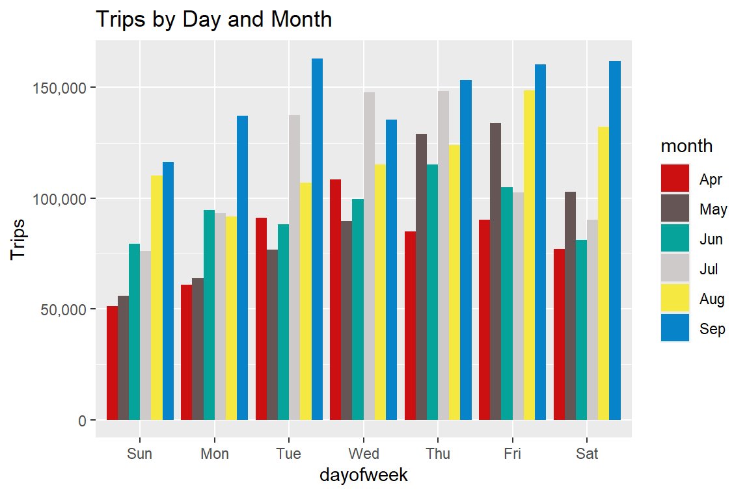

This stacked bar chart shows the number of Uber trips by day of the week and month. Here are some key insights:

1. Weekly Pattern: There's a clear weekly pattern across all months, with weekdays generally busier than weekends.

2. Friday Peak: Friday consistently shows the highest number of trips across all months, likely due to a combination of work commutes and people going out for the weekend.

3. Weekend Dip: Saturday and Sunday show lower trip numbers compared to weekdays, with Sunday typically being the least busy day of the week.

4. Monthly Growth: There's a noticeable increase in trip volume from April to September across all days of the week, indicating overall growth in Uber usage over these months.

5. September Surge: September shows the highest number of trips for every day of the week, suggesting a significant increase in demand. This could be due to factors like return from summer holidays, start of school year, or cooler weather.

6. Midweek Consistency: Tuesday, Wednesday, and Thursday show relatively consistent trip numbers within each month, forming the core of weekday demand.

7. Monday Trend: Mondays generally have fewer trips than other weekdays but more than Sundays, possibly reflecting a transition from weekend to work week.

8. Summer Weekend Increase: The summer months (June, July, August) show a smaller dip in weekend trips compared to spring months, possibly due to increased leisure activities.

9. April vs. May: There's a notable jump in trip numbers from April to May across all days, which could indicate a seasonal shift or a growth in Uber's customer base.

10. Proportional Growth: The relative difference between weekday and weekend trips seems to remain fairly consistent across months, suggesting that growth is proportional across the week.

These insights could be valuable for Uber to:

* Optimize driver availability and incentives for different days of the week
* Plan marketing campaigns targeting specific days or seasons
* Adjust pricing strategies to match demand patterns
* Prepare for the consistent increase in demand from spring to fall
* Investigate the factors behind the September surge to capitalize on or prepare for similar future trends

The data clearly shows both weekly cycles and a monthly growth trend, providing a comprehensive view of how Uber usage varies both within weeks and across the observed months.

**Number of Trips place during months in a year**

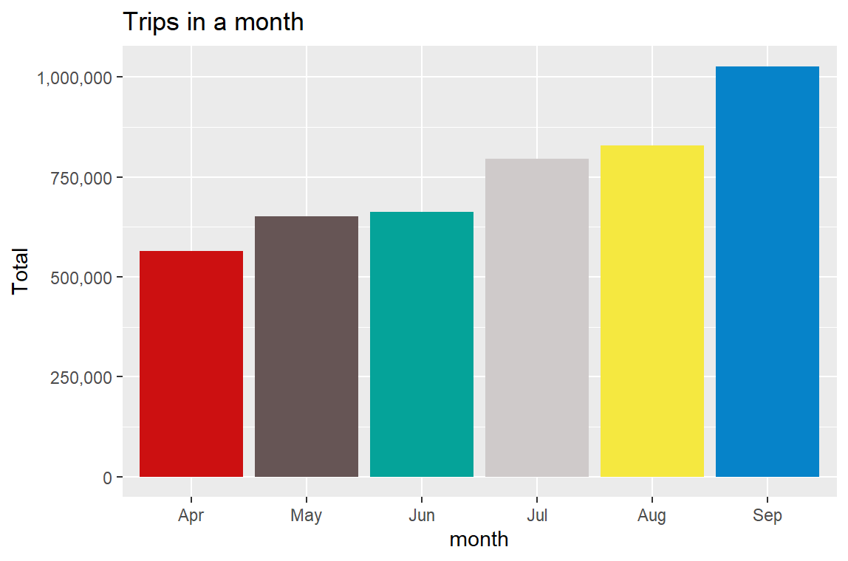

This plot shows the number of Uber trips taken per month from April to September, likely in a single year. Here are some key insights:

1. Consistent growth: There's a clear upward trend in the number of trips from April to September, suggesting growing popularity or expanded service over time.

2. Seasonal impact: The summer months (June, July, August) show higher trip numbers compared to spring (April, May), which could be due to increased tourism or more outdoor activities.

3. September peak: September has the highest number of trips, significantly higher than any other month. This could be due to factors like return to school/work after summer holidays, or cooler weather encouraging more rides.

4. Substantial increase: The number of trips more than doubled from April to September, indicating rapid growth in Uber's usage over just a 6-month period.

5. Monthly variations: While there's an overall upward trend, the rate of increase varies month to month. For example, there's a larger jump from July to August compared to May to June.

6. Scale of operations: Even in the lowest month (April), there were over 500,000 trips, showing Uber's significant presence in the area.

7. Potential factors: The increases could be due to various factors such as marketing efforts, increased driver recruitment, improved app features, or changes in local transportation landscapes.

This visualization effectively demonstrates the growth and seasonal patterns in Uber's trip data, providing valuable insights for business planning and resource allocation.

**Heatmap by Hour and Day**

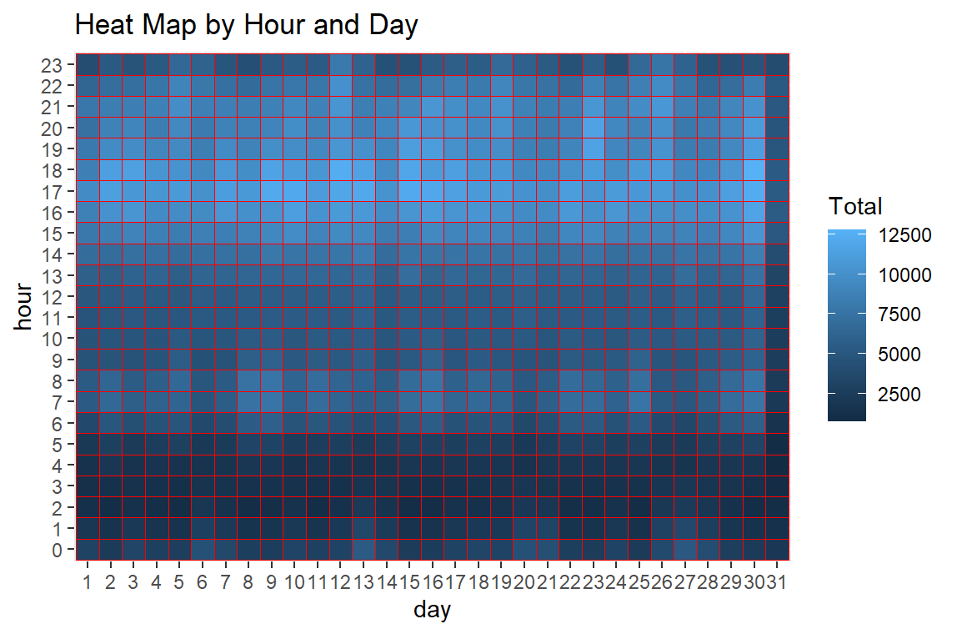

This heat map visualizes Uber trip data by hour of the day and day of the month. Here are some key insights:

1. Peak Hours: The lightest blue areas, indicating the highest number of trips, are concentrated in the evening hours (around 17:00-23:00 or 5 PM to 11 PM). This suggests peak demand for Uber rides occurs in the evening.

2. Morning Rush: There's a secondary, less intense peak in the morning hours (around 7:00-9:00 or 7 AM to 9 AM), likely corresponding to the morning commute.

3. Late Night/Early Morning Lull: The darkest blue areas, indicating fewer trips, are consistently in the early morning hours (around 2:00-5:00 or 2 AM to 5 AM) across all days.

4. Weekend Patterns: While it's hard to definitively identify weekends without date labels, there seem to be some days (possibly weekends) where the evening peak extends later into the night and the morning peak is less pronounced.

5. End-of-Month Surge: There appears to be a slight increase in trip density towards the end of the month (days 28-31), particularly in the evening hours. This could be related to payday or end-of-month activities.

6. Consistent Daily Patterns: The overall pattern of demand is fairly consistent across all days of the month, with the main variations being in intensity rather than timing.

7. Midday Stability: The middle of the day (around 10:00-16:00 or 10 AM to 4 PM) shows a moderate, stable level of trip activity across all days.

8. Data Completeness: The heat map includes data for all 31 days and 24 hours, suggesting a complete month of data was analyzed.

This visualization is valuable for understanding daily and monthly patterns in Uber usage, which could inform driver scheduling, surge pricing strategies, and marketing efforts targeted at specific times of day or month.

**Plot Heatmap by day and month**

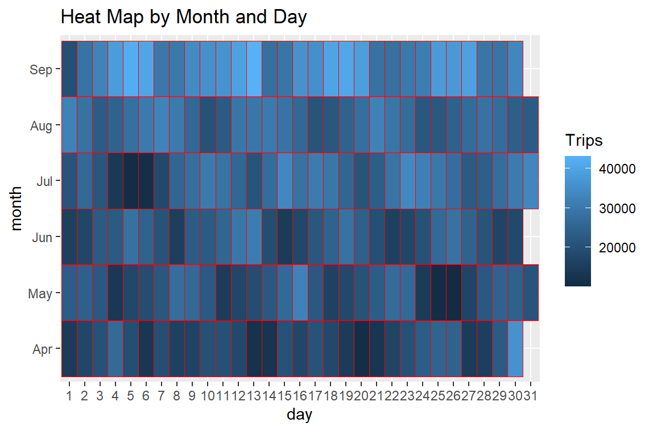

This heat map visualizes Uber trip data across months (April to September) and days of the month. Here are some key insights:

1. Monthly Trend: There's a clear increase in trip volume from April to September, as indicated by the gradual lightening of colors from bottom to top.

2. September Peak: September shows the highest trip volumes overall, with many days in the lightest blue shade, indicating 40,000+ trips per day.

3. Weekend Patterns: There are regular patterns of lighter and darker patches, likely corresponding to weekends (higher trip volumes) and weekdays.

4. End-of-Month Surge: In most months, there's a noticeable increase in trip volume towards the end of the month (days 28-31), possibly related to payday or end-of-month activities.

5. Holiday Effects: There are some notably dark patches (e.g., July 4th), which might correspond to holidays when fewer people use Uber.

6. Mid-Week Lulls: In several months, there are darker patches mid-week, suggesting lower trip volumes on certain weekdays.

7. Consistent Growth: The overall lightening of colors from April to September indicates consistent growth in Uber usage over these months.

8. Data Completeness: Some months (like April and June) seem to have missing data for the 31st, likely because these months only have 30 days.

9. Variability Within Months: Each month shows significant day-to-day variability, with alternating patterns of higher and lower trip volumes.

10. Summer Impact: The summer months (June, July, August) show generally higher trip volumes than spring months (April, May), possibly due to increased tourism or outdoor activities.

This visualization is valuable for understanding seasonal trends, day-of-week patterns, and overall growth in Uber usage. It could inform strategies for driver allocation, surge pricing, and marketing efforts targeted at specific times of the year or month.

**Plot a heatmap by day of the week and month**

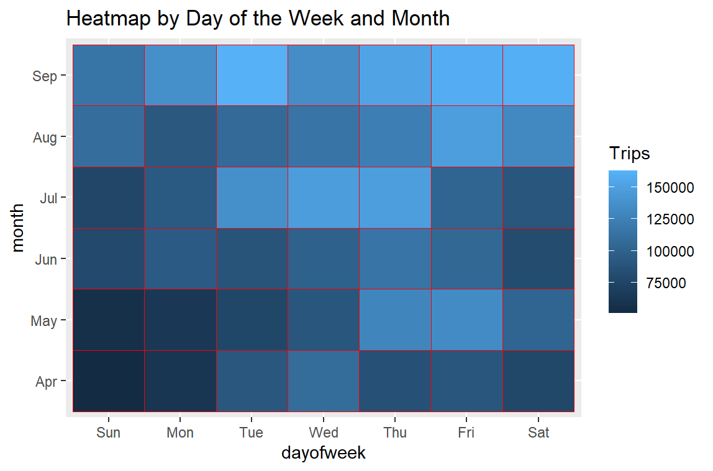

This heatmap visualizes Uber trip data across months (April to September) and days of the week. Here are some key insights:

1. Monthly Growth: There's a clear increase in trip volume from April to September, as shown by the gradual lightening of colors from bottom to top.

2. September Peak: September shows the highest trip volumes overall, with the lightest blue shades across all days of the week.

3. Weekend Patterns: Friday and Saturday consistently show higher trip volumes (lighter blues) across all months, indicating increased Uber usage on weekends.

4. Weekday Trends: Tuesday, Wednesday, and Thursday tend to have moderate trip volumes, as indicated by the medium blue shades.

5. Monday Lull: Mondays often show lower trip volumes compared to other weekdays, especially in the earlier months.

6. Sunday Variation: Sunday trip volumes vary across months, generally increasing from April to September.

7. Seasonal Effects: Summer months (June, July, August) show higher overall trip volumes compared to spring months (April, May).

8. Consistency in Patterns: The day-of-week pattern remains relatively consistent across months, with weekends being busier than weekdays.

9. Gradual Increase: The transition from darker to lighter shades is gradual, suggesting steady growth in Uber usage over the months.

10. Thursday Anomaly: In some months, particularly September, Thursday shows unexpectedly high trip volumes, rivaling or exceeding Friday and Saturday.

11. Holiday Effects: Some anomalies in the pattern (e.g., lower volume on a particular day) might be due to holidays, though this isn't explicitly shown.

This visualization is valuable for understanding both seasonal trends and day-of-week patterns in Uber usage. It could inform strategies for driver allocation, surge pricing, and marketing efforts targeted at specific days of the week or months of the year. The clear weekend peaks and weekday patterns provide insights for optimizing services and resources throughout the week.

**A map visualization of rides in NYC**

This plot represents a map of Uber rides in New York City from April to September 2014. Here are some key insights:

1. Geographic Coverage: The map clearly outlines the shape of New York City, particularly Manhattan and parts of the outer boroughs.

2. Manhattan Density: The densest concentration of rides is in Manhattan, shown by the solid blue area in the center of the upper part of the map.

3. Outer Boroughs: There's significant activity in the outer boroughs, particularly in areas of Brooklyn and Queens adjacent to Manhattan.

4. Airports: Two distinct clusters of activity are visible, likely corresponding to JFK Airport (the lower right cluster) and LaGuardia Airport (the cluster to the right of Manhattan).

5. Bridge and Tunnel Routes: Lighter blue lines connecting Manhattan to other areas likely represent popular bridge and tunnel routes.

6. Water Features: The map clearly shows water features like the East River and Hudson River as white spaces between land masses.

7. Staten Island: The lower left portion of the map shows some activity in Staten Island, though less dense than other boroughs.

8. Long Island: There's a noticeable extension of ride activity eastward, likely representing trips to and from Long Island.

9. New Jersey: While the focus is on NYC, there's some indication of rides crossing into New Jersey, particularly near the Hudson River.

10. Suburban Areas: The outer edges of the map show decreasing density, reflecting fewer rides in more suburban areas.

11. Data Points: Each blue dot likely represents the start or end point of an Uber ride, giving a sense of the volume and distribution of rides.

12. Time Period Snapshot: This map provides a cumulative view of six months of ride data, offering a comprehensive picture of Uber's coverage in NYC during this period.

This visualization effectively demonstrates Uber's extensive coverage across NYC, highlights key areas of activity, and provides insights into travel patterns and popular destinations within the city. It could be valuable for understanding service demand, planning driver allocation, and identifying potential areas for service expansion.